**CHAPTER 1**

**INTRODUCTION**

PESTLE analysis is useful tool for decision makers when evaluating the pros and cons of the strategies used in the business. This analysis is used to evaluate all the outside factors such as political, economic, social, technology, legal and environment. This analysis process brings together the views of customers and business providers, as a results it gives a better understanding, acceptance and successful implementation of the business.

* 1. **Motivation**

Overseeing and growing a fruitful start-up is ready with difficulties from all sides – from keeping workers and speculators upbeat, to fund-raising and always improving your base line. Not each start-up is headed for progress. In reality, getting cash from a financial specialist is no simple accomplishment, however when, guess what states are the most speculator amicable, what financial specialists are searching for and how to assemble an amazing group around your association - at that point you are substantially more prone to discover start-up success.

Jumbo Taxi Service, all the more prevalently known as jumbo, is much the same as some other commercial centres on the web, yet more explicitly into giving Taxi administrations. Jumbo, which begun as an online taxi aggregator and is likewise known to be one of the quickest developing organizations in India, out-beating its rivals Uber and Meru.

As the challenge in the Radio Taxi showcase is expanding at a quicker rate where a few brands are giving taxis to the clients according to the necessities, this work is intended to examine the example for overcoming the adversity of Jumbo taxis which has the best piece of the overall industry and gives benefits in a productive way alongside consumer loyalty.

* 1. **Objectives**

The main objectives of the proposed work are to

* Political Economical Social Technological Legal Environmental (PESTLE) analysis is used by marketers to predict and monitor the macro-environmental (external marketing environment) factors that have an impact on an organization.
* Predict the loop holes is a major factor for threats and weaknesses.
* Apply the changes in area where improvement of tactics is required in terms of business.
* Continuously monitor the report for balanced growth and development of business strategies

**1.3 Outcomes**

The outcomes of the proposed work are

* PESTLE analysis detects the strength and weaknesses of an organization through complete analysis and generation of report.
  + Tracking the loop holes provides improvement in the business point of view.
  + Identifying the weakness and providing a suggestion for further development of business
  + Monitoring the business continuously provides rapid growth in business environment

PESTLE analysis is a [strategic planning method](http://pestleanalysis.com/strategic-planning-tools/) to reduce business threats. By examining the **PESTLE** factors, firms will gain valuable advantages. These advantages help with the idea phase, product development, product launching, content marketing strategies, and other factors to increase success. The advantages of PESTLE analysis are cost effective, providing a deeper understanding of business, alertness to threats, and a method to exploit opportunities. The main advantage of the project is to generate the report for the written user stories and where the detailed view of PESTLE analysis of Jumbo Taxi Service is seen.

**CHAPTER 2**

**LITERATURE SURVEY**

**PESTLE Analysis** is an analytical tool for strategic business planning. PESTLE is a strategic framework for understanding external influences on a business. There are many macro-environment factors that affect strategic planning like new laws, tax changes, trade barriers, demographic change. Macro-environment factors include all the factors that influence an organization, but are out of its direct control. Macro-environment factors tend to have a long term impact.

PESTLE stands for "Political, Economic, Social, Technological, Legal and Environmental" and is used for business and strategic planning, marketing planning, organizational change, business and product development and research reports.  
By understanding these external environments, organizations can maximize the opportunities and minimize the threats to the organization.

Political - What are the political factors that are likely to affect the business?  
Economic - What are the economic factors that will affect the business?  
Sociological - What cultural aspects likely to affect the business?  
Technological - What technological changes that may affect the business?  
Legal - What current and impending legislation that will affect the business?  
Environmental - What are the environmental factors that may affect the business?

In existing PESTLE analysis is a framework or tool used by marketers to analyze and monitor the macro-environmental (external marketing environment) factors that have an impact on an organization. The result of which is used to identify threats and weaknesses which is used in a [SWOT(Strength Weakness Opportunity Threads) analysis](https://www.professionalacademy.com/news/marketing-theories-swot-analysis).

## **Political factors**

These are about how and to what degree a legislature mediates in the economy. This can incorporate – government strategy, political steadiness or weakness in abroad markets, remote exchange approach, charge arrangement, work law, ecological law, exchange confinements, etc. It is obvious from the rundown that political factors frequently affect associations and how they work together. Associations should almost certainly react to the present and foreseen future enhancement and change their advertising approach in corresponding manner.

## **Economic factors**

Financial variables significantly affect how an association works together and furthermore how gainful they are. Components incorporate – monetary development, loan costs, trade rates, swelling, extra cash of customers and organizations, etc.

These elements can be additionally separated into full scale efficient and small scale practical variables. Full scale conservative variables manage the administration of interest in some random economy. Governments use loan fee control, tax collection arrangement and government consumption as their principle instruments they use for this. Small scale monetary variables are about the manner in which individuals spend their wages. This largely affects B2C (Business-to-Consumer) associations specifically.

## **Social factors**

Otherwise called socio-social components, are the territories that include the common conviction and mentalities of the populace. These variables incorporate – populace development, age appropriation, wellbeing cognizance, vocation frames of mind, etc. These elements are exceptionally compelling as they directly affect how advertisers comprehend clients and what drives them.

## **Technological factors**

We as a whole ability pick the innovative scene changes and how this affects the manner in which we advertise our items. Innovative components influence promoting and the administration in three unmistakable ways:

* Better approaches for delivering products and ventures
* Better approaches for disseminating products and ventures
* Better approaches for speaking with target markets
* **Environmental factors**

**These elements have just truly gone to the bleeding edge over the most recent fifteen years or something like that. They have turned out to be essential because of the expanding shortage of crude materials, pollution targets, working together as a moral and maintainable organization, carbon impression targets set by governments (this is a genuine model were one factor could be classes as political and ecological in the meantime). These are only a portion of the issues that advertisers are looking inside this factor. An ever increasing number of customers are requesting that the items they purchase are sourced morally and if conceivable from a supportable source.**

## **Legal factors**

Legitimate elements incorporate - wellbeing and security, square with circumstances, publicizing norms, customer rights and laws, item naming and item security. Plainly organizations need to comprehend what is and what isn't legitimate so as to exchange effectively. On the off chance that an association exchanges comprehensively, so this turns into a precarious territory to get perfectly fine nation that has its own arrangement of standards and guidelines.

**Steps involved in PESTLE analysis for jumbo taxi service**

* Collect the data from various sources
* Cleansing the data
* Transforming the data
* Aggregating the data
* Reporting the result
* Analyze the data
* Loading the data into warehouse

**2.1 Other Types of Analyses**

* **SWOT Analysis**

**SWOT analysis** often talks of the basics of business. People see it as so important because the method evaluates a project or business venture’s strengths, weaknesses, [opportunities](http://pestleanalysis.com/swot-opportunities/), and threats. The initials of these factors make up the acronym SWOT. Business owners or project managers apply this structured planning method to know where their venture stands. The analysis’ benefit is not limited to companies or industries only. You can carry out SWOT for products, places, and even people too. Both new and existing businesses can use it. The process involves stating the business goal. The aim of SWOT is to identify the favourable and unfavourable internal and external factors to reach the goal. You can call the degree to which a firm’s internal environment matches with its external environment as strategic fit. But does not consider all the outside factors.

* [**PEST Analysis**](http://pestleanalysis.com/what-is-pest-analysis/)

PEST analysis studies 4 dimensions, like SWOT. The factors considered in PEST are Political, Economic, Social, and Technological. It is a precise analysis that helps to understand how each of the factors impacts business.  It studies the opportunities and threats section of SWOT, but in more detail.

**Why PESTLE analysis is preferred?**

What a PEST analysis does is force you to list down the factors and visualize them in one place. When you can visually see all the factors in one place it is much easier to identify patterns and connections between those external factors. Additionally, you might not be aware of or at least have full knowledge of all the factors. For example, understanding various complex laws regarding taxes can be confusing for a business owner. So you can invite an external party like a lawyer to optimize the legal section of the PEST analysis for you.

While a SWOT analysis evaluates both external and internal factors that may have an effect on an organization, a PESTLE analysis evaluates only the external factors that may have an influence on an organization and its growth.

A PESTLE analysis, on the other hand, helps a business identify and understand the changes and trends (external factors) in the market and the industry it belongs to. So doing a PESTLE analysis prior to a SWOT analysis could be extremely useful.

Analysing the PESTLE factors will help you when it comes to identifying and figuring out the SWOT factors of your business. For example, listing down all the political, economic, social, technological, legal and environmental factors that may affect your business will, in turn, help you identify the opportunities and the threats to your business rather easily. Hence, a PESTLE analysis could be useful in producing a more comprehensive SWOT analysis.

**2.2 PESTLE Analysis used in existing scenarios**

**2.2.1 Risk identification of the tidal industry in the United Kingdom**

Tidal industry analysis introduces an exhaustive investigation of inexhaustible and particularly tidal vitality through a political, financial, social, innovation, legitimate and ecological (PESTLE) examination approach and by auditing the most modern applicable writing. The examination centers around the United Kingdom gives the positive natural assets for such advances; the quantity of various plan ideas that are at present work in progress just as the exploration financing that has been contributed to the course in the most recent couple of years. Discoveries of the examination distinguish the dangers and numerous partners required at all phases of the tidal vitality ventures advancement from the conceptualization of the plan directly through decommissioning. Huge numbers of the partners present advantages to the tidal designers through financing, motivators and information sharing, and yet they additionally present potential dangers to the eventual fate of ventures. This is generally down to various methodologies of the most vital part of tidal vitality that should be considered, making it hard for technologists and engineers to similarly address all prerequisites. From this examination it tends to be presumed that few of these dangers can be relieved at an early stage giving that specific partners are included at the right phase of a venture.

**Merits:**

From the tidal industry, the best way for developers to mitigate risk is by considering each development stage separately and considering all risks and stakeholders present at that stage. When all dangers at that specific stage have been moderated to enough of a degree, at that point the designers should move onto the next stage. It can also be noted from the findings of this analysis that there are several stakeholders having involvement in multiple areas of the PESTLE analysis which could dictate the future of the market on their own. The UK government is perhaps the biggest of these stakeholders with involvement in providing funding, licensing, the environment, policies and a social obligation to the general public. As long as they continue to commit to the marine energy sector, the short term future at least will have a positive outlook.

**Demerits:**

There are many risks and benefits associated with tidal energy, all of which may be considered as most crucial to different stakeholders due to difference in focus, therefore making it difficult to pinpoint the overall most important factor which must be considered. Tidal energy project makes it difficult to identify the requirements of them, hence the need for a framework in order to ultimately guide developers through the process of getting a tidal energy device to market. Each one of these stakeholders has the potential to delay or even stop a tidal development project if their requirements are not catered for which there is a major risk to technologists and developers.

**2.2.2 The risk study of e-governance based on PEST (political economical social technological) analysis model**

E-governance is the important instrument of government to realize good governance. Public sectors provide information and service to public by using modem ICT (Information and Communication Technology) and Internet technology, in order to foster civil society, building better relationship between government and public and establish transparent and responsible government is important. Yet e-governance is a systematical and complicated project, it will be influenced by many elements. During the development and implementation, it must think much of its negative external environment which is hazard element. Validating the risk of e-governance properly and taking measures to resolve them can provide forecast and protect mechanism for public sectors to develop and implement e-governance effectively.

Presently, the concept of e-governance has not been common in academic. Generally, e-governance is that public sectors use ICT and Internet technology to manage public sphere. Government integrates management and service through internet technology and to realize reorganization of organization structure and work procedure. It transcends the restriction of time, space and sections. Government can supply high quality, standard, transparent and tallying with international standard management and service. E-governance is an imperative new manner to governance when traditional governance has crisis. However, its realization is a Yin Hong College of Literature, Laws and Politics China University of Mining and Technology Xuzhou, lasting and hard process, and it faces risk, so government should make better prepare.

PEST analysis model is a method that strategy consultation advisers review organization’s external environment. PEST is made up of four head letters of alphabet that is political, economic, social and technological. From the four aspects, one can grasp the macro-environment of organizations and evaluate the impact. Political factors are the power, laws and statutes.

Economic factors are the economy systems and structures, resource status, the level of economy developing, and so on. Social factors are ethnic characters, culture conventions, value and faith and education. Technological factors are not only the important inventions, but the new technology, new raw material and their application foreground. For the government and public, the implementation of e-governance has close relation to government reforms and publics' benefits. However, the modem ICT cannot spontaneously develop government institutions and arrangements.

The significance of technology is decided by political, social and cultural when it applied. Although holding advanced instruments, e-governance still faces high risk and challenge. Analyzing the various risks of e-governance based on PEST analysis model, public sectors could understand and evaluate the negative external environment e-governance faces currently and could understand the total direction that agencies develop and adjust it appropriately during the implementation of e-governance.

Finally, for public sectors, it is propitious to combine organization and its circumstance when making policy and supplying service, and according to the development situation of organizations and to select developing strategies, and promote its development bitterly.

**Merits:**

* + - Innovating institution, consummating law system and improving leading competence.
    - Breaking funds bottleneck.
    - Fostering civil society and shortening digital divide.
    - Ensuring information security and promoting information innovation.

**Demerits:**

* + - The plight of institution, policy and political deception.
    - The lack of capital, Information security and innovation issue.
    - The deficiency of citizen participation, digital divide and negative effect of internet media.

**2.2.3 Analysis of outdoor adventure clothing using PESTLE analysis**

In general, consumers in the UK continued to increase their spending on clothing in the last five years regardless of the inflation, economic market change and recession. The holistic market of clothing increases by 4.5% in 2012 and has reached 49.8 billion for 2013 in total. In addition, the outerwear shares a significant proportion of the whole clothing market, since it is both pragmatic and fashionable in the UK and takes approximately 74% of the whole clothing market.

This positive trend indeed indicates a possible bloom in the whole market of outdoor adventure clothing in the next few years. Meanwhile, the data from the market of sport clothing can verify this bloom as well because sports clothing and outdoor adventure clothing have similar functions, manufacturing process and marketing targets. Based on this assumption and the data shown in the UK-based external business environment analysis, it has been a market of approximately 3.5 billion GBP in 2013.

According to the assumption and the analysis presented above, developer can use the data from the sports clothing to roughly forecast the trend and market size of outdoor adventure clothing. By calculating and using the average growth rate (0.2 billion GBP increasing per annum), the market size of the outdoor adventure clothing market can be roughly forecasted to increase to 3.7 billion GBP, 3.9 billion GBP and 4.1 billion GBP for 2014, 2015 and 2016 respectively. It has a quadruple growth rate in comparison to the whole and could eventually occupy round 7% of the clothing market in 2016. Macroscopically, the market of outdoor adventure clothing is to some extent promising and would keep increasing gradually by a steady growth rate.

**Merits:**

* Provides a simple and easy-to-use framework for your analysis.
* Involves cross-functional skills and expertise.
* Helps to reduce the impact and effects of potential threats to your organization.
* Aids and encourages the development of strategic thinking within your organization.
* Provides a mechanism that enables your organization to identify and exploit new opportunities.
* Enables you to assess implications of entering new markets both nationally and globally.

**Demerits:**

* Users can oversimplify the information that is used for making decisions.
* The process must be conducted regularly to be effective and often organizations do not make this investment.
* Users must not succumb to 'paralysis by analysis' where they gather too much information and forget that the objective of this tool is the identification of issues so that action can be taken.
* Organizations often restrict who is involved due to time and cost considerations. This limits the technique's effectiveness as a key perspective may be missing from the discussions.
* User’s access to external quality information is often restricted because of the cost and time needed to collate it.
* Assumptions often form the basis for most of the data used and any decision made based on such data is subjective.

**CHAPTER 3**

**PROPOSED SYSTEM**

**3.1 System architecture**

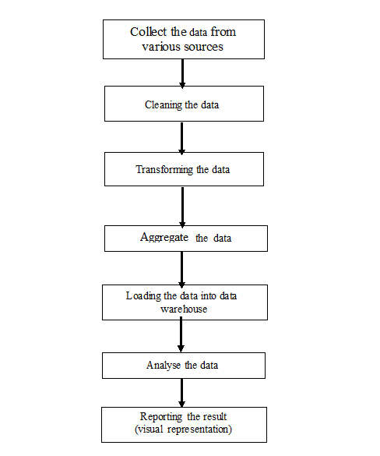

**Figure 3.1** Workflow of Pestle analysis of Jumbo Taxi service

The first step in the analysis is to collect the data. Collecting the data or preparing the data source is the main thing for Analysis in PESTLE way. After collecting the data verify the attributes of the dataset with the attributes of PESTLE factors and then perform cleansing and normalization in the verified dataset. In the part of cleansing remove the unwanted noise in the data so that the data gives the appropriate result for the analysis.

The data can be cleansed using SQL Server Integration system(SSIS) and Python to remove the noise in the data source. Using SQL Server Integration system(SSIS) the data can be transformed and during the process of transformation make the data into a useful dataset for analysis and also aggregate the data as per the attributes using SSIS integration process. After successful Integration we load the data into data warehouse so that we can easily use and view the data for a later purpose.

After loading the data into data warehouse, Business analyst have to analyze the data to get a proper report from PESTLE analyze. After analyzing the data, we start generating the report using SQL Server Report System(SSRS) or Power BI (Business Intelligence) technology, where both are effective and efficient but time consuming process to get the detailed report of analysis.

Power bi is data analysis tool, which can be used for reporting and data analysis from the wide range of data source. Power bi is simple and user-friendly in use which helps business analyst skills and power users to work easily on it. For the complex and huge data analysis power bi is very useful. It is widely used for modeling and structuring of unshaped data.

SSRS stands for SQL Server Reporting Services, it is comprehensive extensible reporting platform. This includes integrated set of processing component and programmatic interfaces. It is used to design, test and deploy the report. Mainly this is a server-based platform.

In this work we prefer Power BI because it has more graphical component as compared to SSRS which makes power bi more efficient and easy to use, whereas SSRS has the more manual effort for analysis and generating the reports. Power bi will be helpful to generate the report on the basis of cloud data although it will analyze and generate the report on the basis of relational storage which can access through your computer but SSRS is only useful where your data resides on the system. SSRS is a vintage solution for publishing or generating the reports whereas power bi is latest and user-friendly tool.

**3.2 Description**

Jumbo taxi service is regarded as the fastest growing taxi-sharing company. But it has also seen various controversies regarding the taxi industry like minimum wage complications, and banning in worldwide countries. However, it still continues to grow.

## **Political factors**

Jumbo has faced controversy. In its initial development, Jumbo didn’t have clear regulations. It was difficult to pinpoint insurance fraudulence, whether it is taxi driver’s fault, or the company’s itself. So, we have collected datasets by analysing various political factors. The political factor is applied for all the stack holders of Jumbo taxi service. This will include all the government policies, rules and regulations. Beyond that, this political factors includes political stability and instability for the best analysis. The dataset includes the driver insurance policy, company insurance policy and customer insurance policy. This PESTLE analysis will also comprise about the tax policy and other restrictions

There are political discussions about minimum wage laws in the taxi industry, and whether Jumbo was abiding by these rules. The government requires commercial licenses as well, requiring Jumbo [to provide that documentation](http://pestleanalysis.com/political-factors-affecting-business/). The wages are the major concern for the drivers and it has to be accurate, so that our taxi service can satisfy both the drivers and the customers. Owing to this, the dataset includes the data such as distance, categories of vehicle, rate per km and the salaries of employee working for the jumbo taxi service in different designation which also includes the salaries of the employees before and after strike.

## **Economic factors:**

The industry that jumbo operates in is the sharing economy. [It means that this economy is based on sharing physical or intellectual resources](http://pestleanalysis.com/economic-factors-affecting-business/). In this case, Jumbo hires drivers to respond to customer and drive them to a location. It’s often deemed cheaper than taxis and easier to schedule an appointment. The offers should be provided to the customer for their convenience and it should be easily available to the customers. The offer code should be given to the customer, so that they can easy apply the promo code for their ride. This will grab the attention of customers and the customers will show interest in riding. We have to analyse the Financial patterns, development rates, industry development, regular elements, global trade rates, International exchange, work costs, purchaser discretionary cash flow, joblessness rates, tax collection, expansion, loan costs, accessibility of credit, money related approaches, crude material expenses, and so on.

Jumbo has grown exponentially since its initial launch. But countries have banned or restricted its services due to Jumbo having an unfair competition against regular taxis. Other companies in this industry face debate, but Jumbo’s fast development has led them to be the focus point. By considering the above aspects, the dataset includes the fair data, wage data, insurance amount, tax details for both technical and non-technical staffs of jumbo taxi service and also it includes various payment options for the better service to the customers.

One thing is certain, Jumbo has grown at an alarming rate — showing there is economic potential in this market. But as Jumbo grows larger, other platforms like Lyft must fight to stay relevant.

## **Social factors: Easy availability**

Customers of Jumbo enjoy its ease of accessibility. Booking rides with jumbo taxi service is made comfortable with the help of an android application. It requires less communication and it is known for its user friendliness The cheaper price is enticing to many, which has led to the explosion of Jumbo growth all over India.

Social factors will also include job opportunity provided by the jumbo taxi service, Women safety, authentication will also be provided with OTP, response time, insurance for customer. While considering the above aspects in collecting the dataset for the social factors. The dataset includes the fair data, wage data, insurance amount, GPS tracking, tax details for both technical and non-technical staffs of jumbo taxi service and also it includes various payment options for customers.

As consumers enjoyed their rides, they posted about their experience on social media sites. [Word of mouth spread awareness quickly](http://pestleanalysis.com/social-factors-affecting-business/). But with the popularity increase, prices in major cities rose too. Good for Jumbo, but not welcomed by riders. Social factors will also include job opportunity provided by the jumbo taxi service, Women safety, authentication will also be provided with OTP, response time, insurance for customer.

While considering the above aspects in collecting the dataset for the social factors. The dataset includes the fair data, wage data, insurance amount, GPS tracking, tax details for both technical and non-technical staffs of jumbo taxi service and also it includes various payment options for customers. Still, because of the ease of use, customers choose Jumbo frequently. The more accessibility Jumbo provides; the more people will use its services rather than taxis or even public transportation.

## **Technological factors:**

[Jumbo spread like wildfire through social media](http://pestleanalysis.com/swot-analysis-for-uber/). People explaining their riding experiences online spread and share stories. It encouraged new users to do the same. Buyers are searching for cheaper transportation options and Jumbo fulfilled this need.

Consumers make booking through the application. An estimate for the ride cost can appear in the application — it depends on many factors like drop off location, traffic and weather. They can pay for the ride up front through the application too. And drivers who are on duty will respond to the booking and pick up the passengers to take them to their destination.

While considering the above aspects in collecting the dataset for the technological factors, the technical factors will also include payment mode for the better convenience of the customers, GPS tracking, emergency contact, Location sharing, estimated fare calculation based on weather, Traffic, Peak time, providing offline mode to book ride for the convenience of the customers when there is no internet connection.

There are various payment modes such as jumbo wallets, UPI, Debit Card, Paytm, etc., The dataset includes the booking details, online or offline for jumbo taxi service and also it includes various payment options for finding which mostly attract the customers and getting the data of most preferable payment mode and booking mode. The application is incredibly important to Jumbo. It can’t function if the application goes down or suffers difficulties. The company must ensure everything is working, reliable and ready to go.

## **Legal factors: Banning**

Legal factors relate to the laws, regulation and legislation that will affect the way the business operates. Laws have been introduced to prevent companies from changing product prices without informing customers. These factors overview the legal elements. Often, start-ups link these elements to the political framework. Many legal issues can affect a company that does not act responsibly. Legal factors include the insurance policies, License details, Collaboration details of the jumbo taxi service. The dataset includes details such as license expiry date, insurance policy of customer, driver, cab and the collaboration includes bike service, auto service along with cab service.

## **Environmental factors: Questionable responses**

Jumbo’s effect on the environment is ever shifting. Many believe it increases traffic congestion and fuel usage. But studies have shown Jumbo hasn’t increased congestion. People may use Jumbo instead of public transportation. Analysts will have to compare Jumbo fuel usage versus public transit versus own transportation for a thorough analysis of Jumbo’s environmental impact. As many different factors can contribute to the final number.

While considering the above aspects in collecting the dataset for the environmental factors. The dataset includes the response time, vehicle categories for customer choices, request and response time of booking for providing better services to customers and fuel consumption based on each category of vehicle and analyse dataset by loading them into data warehouse and generate the report stating the result in it with a better visual understanding.

**3.3 Technologies used**

* Microsoft SQL Server
* SQL Server Integration Services
* SQL Server Reporting Services
* Python
* Power BI

**3.4 Modules description**

The main computerized modules are as follows:

* Data Collection
* Extraction, Transformation, Loading (ETL Process)
* Report generation

**3.4.1 Data Collection**

Collect the data from various sources based on the attributes required for the analysis for the Jumbo Taxi service. Data collection is one of the important   
phase for analysis in which the attributes collected by business   
analysts can be used for verifying whether the dataset prepared is suitable or not for the analysis. The dataset will include the attributes that satisfy the political, economic, social, technological, environmental and legal factors through which we can finally come up with a conclusion.

**3.4.2 ETL Process**

ETL stands for Extract, Transform and Load. SQL server integration services(SSIS) is a tool used for data migration which is connected with Microsoft SQL server. The Primary feature of SSIS is for data warehousing where we perform extract, transform and load (ETL) operations and so it is considered as one of the ETL tools. ETL is a process of moving data from source to destination where in between we perform some transformation to the data as required.

* **Extract**

During extraction, the desired data is identified and extracted from many different sources, including databases systems and applications. Business analyst extract data from various sources like excel, flat files, database storage and so on. The Term Extraction Transformation in SQL Server Integration Service first extracts terms from the text present in the data source and then writes the extracted terms to a transformation output column. During this process we use corresponding source extraction functions available in SQL Server Integration Service as per the data source type. For Excel source file we use Excel Data source, for CSV formatted file we use Flat File Data Source and so on.

* **Transform:**

After extracting the data from its corresponding data source it has to be physically transported to the target system or to an intermediate system for further processing. Depending on the chosen way of transportation, some transformations can be done during this process. In [SSIS](https://www.tutorialgateway.org/ssis/), business analyst can perform term extraction transformations only on the column with the [dt_wstr] and [dt_ntext] data type. If the data type of the input column is different from these two then [SSIS Data Conversion](https://www.tutorialgateway.org/ssis-data-conversion/) Transformation is used to convert other Data Types to [dt_wstr] and [dt_ntext] data type. Other than Data Conversion Transformation SSIS has many more Transformations like Merge, Merge Join, Union All, Conditional Split, Row Sampling, Percentage Row Sampling, Multicast, Derived Column and etc.

* **Load:**

It will load the data into the target database and reporting applications. In this the destination type is selected as per the user choice. In this work SQL Database storage is selected as destination for its efficiency and data availability for later use in a shared resource creating a data warehouse.

**3.4.3 Report Generation**

After data gets extracted and loaded into data warehouse next process is to generate the report. The report is generated for each factors politically, economically, socially, technologically, legally and environmentally based on the attributes which are used to analyze those factors and business analyst use these reports to get to some conclusion.

**CHAPTER 4**

**SYSTEM IMPLEMENTATION**

**4.1 Data cleansing using SSIS**

Data cleansing (or ‘data scrubbing’) is detecting and then correcting or removing corrupt or inaccurate records from a record set. After cleansing, a data set will be consistent with other similar data sets in the system. The inconsistencies detected or removed may have been caused by different data dictionary definitions of similar entities in different stores, or caused by user entry errors or data which was corrupted in transmission or storage. Pre-processing the data will also guarantee that it is unambiguous, correct, and complete.

The actual process of data cleansing may involve removing typos or validating and correcting values against a known list of entities. The validation may be strict such as rejecting any address that does not have a valid ZIP code or fuzzy such as correcting records that partially match existing known records. Data cleansing differs from data validation. Validation almost invariably means data is rejected from the system at entry and is performed at entry time, rather than on batches of data.

In case of a data warehouse, let us assume that the data of customer ride details and driver experience etc. are going to be load into a database by choosing the fact tables and dimension tables required to generate the relational model.

Then start the task by creating a SQL Server Integration Service project and then add a data flow task to the control flow. In the added data flow task, it will start the operations by adding a flat file source and pointing the csv file to the flat file source.

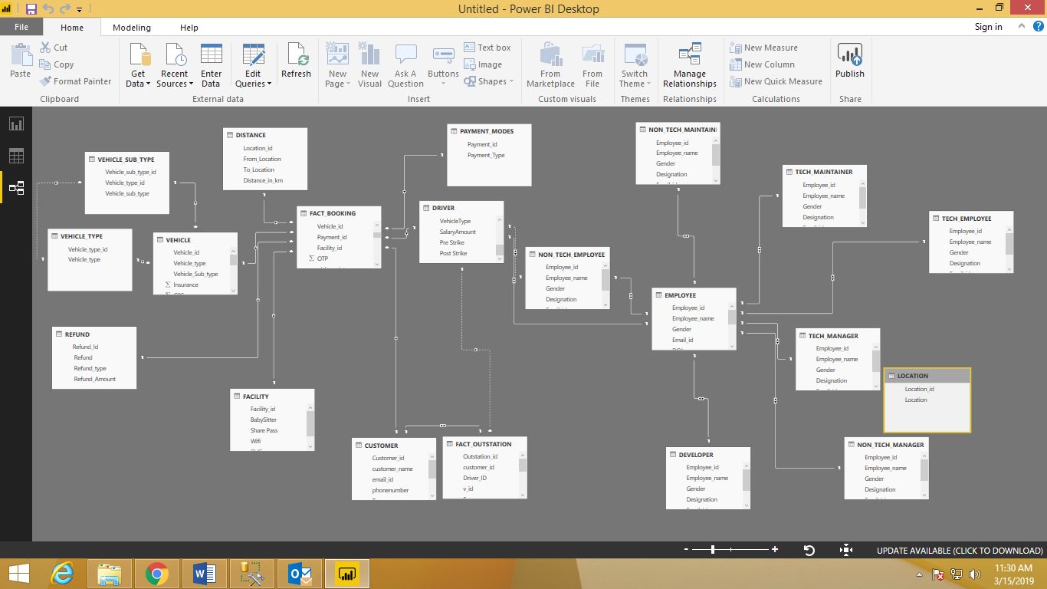

**Figure 4.1:** Data warehouse dimension modelling

**Figure 4.1** discuss about the relational data warehouse dimension and modelling (star schema) that shows the fact table connected with n number of dimension table. In the task of updating these tables with the data we received from the text/excel file Vehicle ID needs to be identified by performing a lookup on the vehicle table by using a vehicle ID while Faculty ID needs to be identified by doing the lookup to faculty with ID field. Similarly, Payment ID needs to be identified needs to be identified from payment and Refund Id and refund type connected to Payment table to find the Payment ID.

**4.2 Data cleansing using python**

Large amount of time was spent for cleaning datasets and getting them down to a form with which they can work. There are numerous modules and packages available to cleansing, training and testing the data.

import pandas as pd #to import files

import numpy as np #to convert data into dataframe (rows and columns)

Pandas is a high-level data manipulation tool which is built on the Numpy package. Numpy package is used to convert the data into dataframe. The key data structure of Numpy is called the DataFrame. DataFrames allow you to store and manipulate tabular data in rows of observations and columns of variables.

A Data Frame is created out of the CSV file ‘fact_linear_regression.csv’ in this work. In the examples below, we pass a relative path to “pd. read_csv” to read the CSV file, meaning that all of the datasets are in a folder named Datasets in our current working directory. The dataframe name used here is ‘df’.

df = pd. read_csv (“C:\\Users\\Datasets\\Documents\\fact_linear_regression.csv”)

df. head ([value])

The function dataframe.head([n]) returns the first n rows for the object based on position. It is useful for quick testing if your object has the right type of data in it.

df.info ()

Pandas **dataframe.info()** function is used to get a concise summary of the dataframe. It comes really handy when doing exploratory analysis of the data. To get a quick overview of the datasets we use the dataframe.info () function.

df. Describe ()

Pandas dataframe.describe () is used to view some basic statistical details like percentile, mean, etc. of a dataframe or a series of numeric values.

Python offers multiple options for developing GUI (Graphical User Interface). Out of all the GUI methods, **tkinter** is most commonly used method. It is a standard Python interface to the Tk GUI toolkit shipped with Python. Python with tkinter outputs the fastest and easiest way to create the GUI applications.

from tkinter import* #to import tkinter package in python

Label() #to display the text label for an entry or a button in UI

LabelFrame() #to create a container display for complex windows layout

Entry() #to create a text box in UI

Button() #to create a button in UI

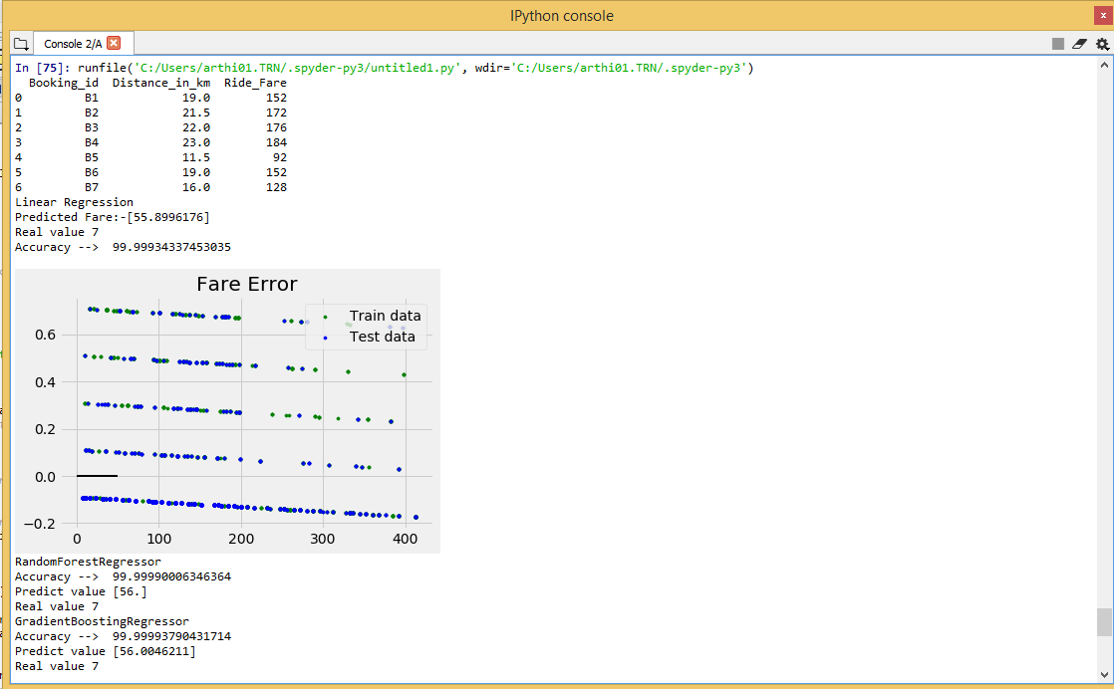

**Figure 4.2** Linear Regression Diagram

Using Linear Regression analysis, the dataset is trained for distance and its fare calculation. First the 80% of the datasets is trained and the trained data is plotted to check whether the 20% of test data matches or not. The trained data is shown in blue colour dots and tested data are plotted in black colour dots. If the plotted dots are most probably same, it means the datasets are correct for fare calculation in taxi service.

**4.3 SQL Server Analysis Services**

SQL Server Analysis Services is the technology from the Microsoft Business Intelligence stack, by using this Online Analytical Processing (OLAP) solutions were developed. In simple terms, SSAS can be used to create cubes using data from data marts or data warehouse for deeper and faster data analysis.

Cubes are multi-dimensional data sources which have dimensions and facts (also known as measures) as its basic constituents. From a relational perspective dimensions can be thought of as master tables and facts can be thought of as measureable details. These details are generally stored in a pre-aggregated proprietary format and users can analyse huge amount of data and slice this data by dimensions very easily. Multi-dimensional expression (MDX) is the query language used to query a cube, similar to the way T-SQL is used to query a table in SQL Server.

A typical higher level cube development process using SSAS involves the following:

* Reading data from a dimensional model.
* Configuring a schema in Business Intelligence Development Studio (BIDS).
* Creating dimensions, measures and cubes from this schema.
* Fine tuning the cube as per the requirements.
* Deploying the cube.

**4.4** **SQL Server Reporting Services**

SQL Server Reporting Services (SSRS) is a server-based report generating software system from Microsoft. It is part of a suite of Microsoft SQL Server services, including SSAS (SQL Server Analysis Services) and SSIS (SQL Server Integration Services). Administered via a Web interface, it can be used to prepare and deliver a variety of interactive and printed reports. The SSRS service provides an interface into Microsoft Visual Studio so that developers as well as SQL administrators can connect to SQL databases and use SSRS tools to format SQL reports in many complex ways. It also provides a 'Report Builder' tool for less technical users to format SQL reports of lesser complexity.

In this project datasets were collected based on attributes needed for various factors from various resources and generated some data for some attributes which are not available in any resources.

**4.5 Implementation results**

The reports are generated based on the following factors:

* **Political Factor**

|  |  |  |  |  |
| --- | --- | --- | --- | --- |
| Driver id | Full Name | Pre Strike | Post Strike | Difference |
| D1000 | Jarrad Maidment | 18610.78 | 19541.31 | 5% |
| D2000 | Dwayne johnson | 19000.28 | 20110.38 | 6% |
| D3000 | Scott Stenier | 17250.00 | 18250.00 | 5.5% |
| D4000 | Jon Snow | 19000.00 | 20000.00 | 5.5% |
| D5000 | John Morrison | 20010.00 | 22000.00 | 6.3% |
| ……. | …….. | ……. | …… | ……. |

**Figure 4.3** Political Analysis of Driver Salary

The political environment has a huge impact on Jumbo as it is globally present. Hence, the company must consider the taxation and rules of a country. Here the analysis for the salary of the driver during post-strike and analysis for the salary of driver during post-strike is done for finding politically how they are strong or to know what are their weakness and try to overcome that flaw in future.

* **Economical Factor**

Inthis the prediction is done using the Linear Regression analysis. Train the datasets of distance for distance fare calculation. First, train the 80% of the datasets to plot the trained data to check whether the 20% testing data are matched or not. The trained data show in blue colour dots and tested data are plot in black colour dots. If the plotted dots are most probably same means our datasets are correct for our fare calculation in taxi service.



**Figure 4.4:** Ride Fare Prediction using Linear Regression Analysis

* **Social Factor**

Analyze the population of employee based on each category and sub-category to show how they provide jobs and give important to female safety by appointing female employees for female customers.

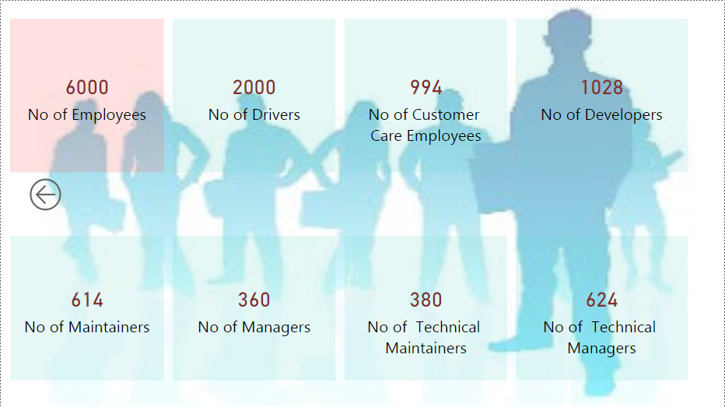

**Figure 4.5:** Analyse the employee count on each category

* **Technological Factor**

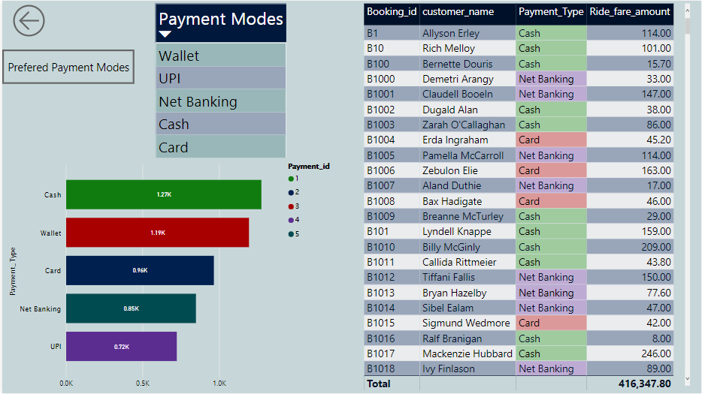

**Figure 4.6:** Analysis of payment modes

Analyse the customer preferences on payment mode, because now a day’s payment is the most important thing, according to each customer’s point of view payment method can change, one can wish to pay through cash or online transaction such as internet banking, UPI, wallet, card etc. To satisfy the customer needs analyse the customer thoughts on payments and make the technology efficient for fast payment transaction.

* **Legal Factor**

Legal factors include legal issues in driving the cabs based on the year and month. They teach about insurance policy which should be renewed within a time period. For that we analyze the insurance expiry date and year to alter the corresponding cabs to keep updated to avoid legal issues.

* **Environmental Factor**

In this it isspoken about the current environmental situation they provide to the taxi services like cab, auto and bike. While providing correct vehicle to the correct environment they satisfy the customer travel experience and avoid them unwanted traffic and give them a joy of ride. It also provides several types of cab services like mini, macro, prime sedan, lux, prime suv based on the number of passengers they can choose for the cab services and their fare also get changed based on the cab they drive.

**CHAPTER 5**

**CONCLUSION**

Jumbo is a big-shot in the shared economy. It’s known for its cheapness, ease of use, and controversies. Countries around the world have been open about whether they support or don’t support Jumbo. The company faces many struggle in their environment. But its popularity continues to grow. Even when the prices rise, it still stays competitive against taxis. Consumers enjoy using the application to book rides and may even choose it over public transportation because of the experience. But the ways the company hurt the environment requires more investigation.

The project can be further enhanced with new methods and attempt to decrease the fault made by jumbo taxi service to improve and upgrade the business needs. In addition, in order to expand and provide the cab services in some village areas around the world with affordable costs for everyone and providing a great experience in their journey will gain raise in their business fields.

**REFERENCES**

1. ARM Research (2005). “AMR Research releases ERP market report showing overall market growth of 14% in 2004” [Online]. Boston: ARM research. http://www.amrresearch.com/Content/ View.asp?pmillid=18358 [Accessed 21/02/06]
2. Perkins, D.H. (1997). “History, politics, and the sources of economic growth: China and the East Asian way of growth”. In: Itoh, F. (eds.), China in the twenty-first century: politics, economy, and society, pp. 25-47. Tokyo: United Nations University Press. Reimers, K. (2002). “Implementing ERP systems in China”. In: HICSS 2002 Hawaii. Proceedings of the 35th Annual Hawaii International Conference on System Sciences. 7-10 January 2002, Hawaii. IEEE Computer Society, Washington, D.C.
3. Yusuf, S., Nabeshima, K. and Perkins, D.H. (2006). Under new ownership: privatizing China’s state-owned enterprises. California: Stanford University Press and Washington: The World Bank.
4. McManus, J., Li, M. and Moitra, D. (2007). China and India: opportunities and threats for the global software industry. Oxford: Chandos Publishing.
5. Renewable UK Web Page. Wave and Tidal Energy in the UK 2013: Conquering Challenges, Generating Growth. Available online: http://www.renewableuk.com/en/publications/index.cfm/ wave-and-tidal-energy-in-the-uk-2013 (accessed on 7 June 2013).
6. Moro Visconti, Roberto, Healthcare Public-Private Partnerships in Italy: Assessing Risk Sharing and Governance Issues with PESTLE and SWOT Analysis (June 25, 2016).